Course: Programming Fundamental –ENSF 337

Lab #: Lab 5

Instructor: M. Moussavi

Student Name: Jiho Kim

Lab Section: B01

Date submitted: Oct 14, 2019

EXERCISE C

#include <stdio.h>

// Students should add the defintion of macro LARGEST_OF_THREE here.

#define LARGEST_OF_THREE(a, b, c) (( (a>b)? a:b) < c)? c : ( (a>b)? a:b)

int main(void)

{

double x = 0.300, y = 0.500, z= 0.999;

double largest = LARGEST_OF_THREE(x, y, z);

printf("\nTest 1: the largest value is %f", largest);

printf("\nTEST 2: the lagerst value is %f", LARGEST_OF_THREE(345, 99.8, 10));

printf("\nTEST 3: the lagerst value is %f", LARGEST_OF_THREE(4, 9.8, 10.0));

printf("\nTEST 4: the lagerst value is %f", LARGEST_OF_THREE(4.5, 4.5, 4.5));

printf("\nTEST 5: the lagerst value is %f", LARGEST_OF_THREE(0.0, 0.0, 0.0));

printf("\nTEST 6: the lagerst value is %f",

LARGEST_OF_THREE(x * 10, y * 2 , z * 3));

return 0;

}

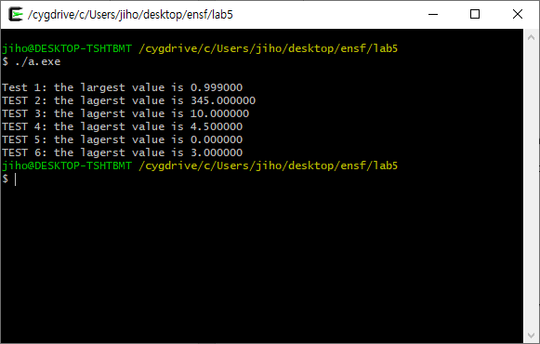

EXERCISE D

/* File: lab5exD.c

* ENSF Fall 2019- lab 5 - Exercise D

*/

#include "lab5exD.h"

#include <stdio.h>

#include <math.h>

#include <string.h>

int main(void)

{

Point alpha = { "A1", 2.3, 4.5, 56.0} ;

Point beta = { "B1", 25.9, 30.0, 97.0 } ;

printf ("Display the values in alpha, and beta: ");

display_struct_point(alpha);

display_struct_point(beta);

Point *stp = &alpha;

printf ("\n\nDisplay the values in *stp: ");

display_struct_point(*stp);

Point gamma = mid_point(stp, &beta, "M1");

printf ("\n\nDisplay the values in gamma after calling mid_point function.");

printf ("Expected result is: M1 <14.10, 17.25, 76.50>");

printf("\n\nThe actual result of calling mid_point function is: ");

display_struct_point(gamma);

swap (stp, &beta);

printf ("\n\nDisplay the values in *stp, and beta after calling swap function.");

printf ("Expected to be:\nB1 <25.90, 30.00, 97.00>\nA1 <2.30, 4.50, 56.00>");

printf("\n\nThe actual result of calling swap function is: ");

display_struct_point(*stp);

display_struct_point(beta);

printf("\n\nThe distance between alpha and beta is: %.2f. ", distance(&alpha, &beta));

printf ("(Expected to be: 53.74)");

printf("\nThe distance between gamma and beta is: %.2f. ", distance(&gamma, &beta));

printf ("(Expected to be: 26.87)");

return 0;

}

void display_struct_point(const Point x)

{

printf("\n%s <%.2lf, %.2lf, %.2lf>", x.label, x.x, x.y, x.z);

}

Point mid_point(const Point* p1, const Point* p2, const char* label)

{

// This function is incomplete and must be completed by the students

// YOU ARE NOT ALLOWED TO USE ANY STRING LIBRARY FUNCTIONS IN THIS FUNCTION

Point middle = {"?", 0, 0};

for(int i = 0; i < 10 || label[i] == '\0'; i++){

middle.label[i] = label[i];

}

middle.x = (p2->x - p1->x)/2 + p1->x;

middle.y = (p2->y - p1->y)/2 + p1->y;

middle.z = (p2->z - p1->z)/2 + p1->z;

return middle;

}

void swap(Point* p1, Point *p2)

{

Point p3;

p3.x = p1->x;

p1->x = p2->x;

p2->x = p3.x;

p3.y = p1->y;

p1->y = p2->y;

p2->y = p3.y;

p3.z = p1->z;

p1->z = p2->z;

p2->z = p3.z;

return;

}

double distance(const Point* p1, const Point* p2)

{

// This function is incomplete and must be completed by the students

// NOTE: IN THIS FUNCTION YOU ARE NOT ALLOWED TO USE THE ARROW OPERATOR ->

double distance;

distance = sqrt(pow(((*p2).x - (*p1).x) , 2) + pow(((*p2).y - (*p1).y) , 2) + pow(((*p2).z - (*p1).z) , 2) );

return distance;

}

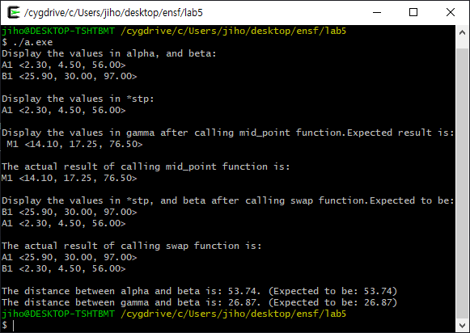

Exercise E

// lab5exE.c

// ENSF 337- Fall 2019, Exercise E

#include "lab5exE.h"

#include <stdio.h>

#include <math.h>

#include<string.h>

int main(void)

{

Point struct_array[10];

int i;

int position;

populate_struct_array(struct_array, 10);

printf("\nArray of Points contains: \n");

for(i=0; i < 10; i++)

display_struct_point(struct_array[i], i);

printf("\nTest the search function");

position = search(struct_array, "v0", 10);

if(position != -1)

printf("\nFound: struct_array[%d] contains %s", position,

struct_array[position].label);

else

printf("\nstruct_array doesn't have label: %s.", "v0");

position = search(struct_array, "E1", 10);

if(position != -1)

printf("\nFound: struct_array[%d] contains %s", position,

struct_array[position].label);

else

printf("\nstruct_array doesn't have label: %s.", "E1");

position = search(struct_array, "C5", 10);

if(position != -1)

printf("\nFound: struct_array[%d] contains %s", position,

struct_array[position].label);

else

printf("\nstruct_array doesn't have label: %s.", "C5");

position = search(struct_array, "B7", 10);

if(position != -1)

printf("\nFound: struct_array[%d] contains %s", position,

struct_array[position].label);

else

printf("\nstruct_array doesn't have label: %s.", "B7");

position = search(struct_array, "A9", 10);

if(position != -1)

printf("\nFound: struct_array[%d] contains %s", position,

struct_array[position].label);

else

printf("\nstruct_array doesn't have label: %s.", "A9");

position = search(struct_array, "E11", 10);

if(position != -1)

printf("\nFound: struct_array[%d] contains %s", position,

struct_array[position].label);

else

printf("\nstruct_array doesn't have label: %s.", "E11");

position = search(struct_array, "M1", 10);

if(position != -1)

printf("\nFound: struct_array[%d] contains %s", position,

struct_array[position].label);

else

printf("\nstruct_array doesn't have label: %s.", "M1");

printf("\n\nTesting the reverse function:");

reverse(struct_array, 10);

printf("\nThe reversed array is:");

for(i=0; i < 10; i++)

display_struct_point(struct_array[i], i);

return 0;

}

void display_struct_point(const Point x , int i)

{

printf("\nstruct_array[%d]: %s <%.2lf, %.2lf, %.2lf>\n",

i, x.label, x.x, x.y, x.z);

}

void populate_struct_array(Point* array, int n)

{

int i;

char ch1 = 'A';

char ch2 = '9';

char ch3 = 'z';

for( i = 0; i < 10; i++)

{

/* generating some random values to fill them elements of the array: */

array[i].x = (7 * (i + 1) % 11) * 100 - i /2;

array[i].y = (7 * (i + 1) % 11) * 120 - i / 3;

array[i].z = (7 * (i + 1) % 11) * 150 - i /4;

if(i % 2 == 0)

array[i].label[0] = ch1++;

else

array[i].label[0] = ch3--;

array[i].label[1] = ch2--;

array[i].label[2] = '\0';

}

}

int search(const Point* struct_array, const char* label, int n)

{

// Students should complete the definiton of this function

// NOTE: YOU ARE NOT ALLOWED TO USE LIBRARY FUNCTION strcmp IN THIS FUNCTION

int counter = 0;

for(int i = 0; i < n; i++){

while(label[counter] != '\0'){

if(label[counter] == struct_array[i].label[counter]){

counter++;

} else{

break;

}

if(label[counter] == '\0')

return i;

}

counter = 0;

}

return -1;

}

void reverse (Point *a, int n)

{

// Students should complete the definiton of this function

Point b;

for(int i = 0; i < n/2; i++){

b = a[i];

a[i] = a[n-i-1];

a[n-i-1] = b;

}

return;

}

